Date:

TASK 10: Implement the QAOA algorithm

Aim: To implement the Quantum Approximate Optimization Algorithm (QAOA) using Qiskit and PyTorch to solve the Max-Cut problem, a classical NP-hard problem.

1 Mathematical Model of the QAOA Algorithm
1.1 Max-Cut Problem Formulation
Given a graph = ( , ) with weighted adjacency matrix |  |  |  |  | , the Max-Cut objective is
 | ( ) = ∑_{( , )} |  | .
where{0,1} indicates the partition of node .
The goal is { , } | ( )
1.2 QAOA Ansatz
The QAOA prepares a quantum state parameterized by angles |  |  |  |  | ⃗
 |  |  |  |  | ⃗, .
 | ⃗ |  | ∑ |  | +〉
 | ⃗, 〉 = |  |  |  | +〉
=∑_{(,)} | (cost Hamiltonian)

= ∑ (mixer Hamiltonian)

1.3 Expectation Value

⃗ | = 〈 | ⃗ | |H | | ⃗ | 〉, the optimization is performed
The objective is to maximize ⃗, | = 〈 | ⃗, | |H | | ⃗, | 〉, the optimization is performed
using a classical optimizer (Adam with finite-difference gradients).

2 Algorithm - QAOA Algorithm

- Graph Construction

Define adjacency matrix W.

Build a NetworkX graph for visualization.

- Classical Baseline

Use brute-force enumeration to compute the optimal Max-Cut value (ground truth).

- QAOA Circuit Construction

Initialize qubits in |+〉 .
Apply alternating cost and mixer unitaries for depth .

Use controlled- rotation gates to implementinteractions.

- Expectation Calculation

Simulate circuit using Qiskit Aer statevector simulator.

Compute expected cut value from measurement probabilities.

- Hybrid Optimization

 | Parameters | ⃗ | initialized randomly.
 | Parameters | , | initialized randomly.

Compute finite-difference gradients of expectation. Update parameters using PyTorch Adam optimizer.
- Circuit Visualization

Draw initial and optimized QAOA circuits using qiskit.visualization.

3 Program

#!pip install qiskit qiskit-optimization torch networkx numpy #!pip install qiskit-aer
#!pip install pylatexenc

import os
import numpy as np
import networkx as nx
import torch

from qiskit import QuantumCircuit from qiskit_aer import Aer
from qiskit.quantum_info import Statevector
from qiskit_optimization.applications import Maxcut
from qiskit_optimization.problems import QuadraticProgram

- Visualization imports import matplotlib

- Use Agg backend in headless environments so saving works even without GUI matplotlib.use(os.environ.get("MPLBACKEND", "Agg"))

import matplotlib.pyplot as plt

- -------------------------
- Problem definition
- -------------------------
def make_graph():
# Example: 4-node graph (same as Qiskit tutorial)
w = np.array([
[0.0, 1.0, 1.0, 0.0],
[1.0, 0.0, 1.0, 1.0],
[1.0, 1.0, 0.0, 1.0],
[0.0, 1.0, 1.0, 0.0]
])

  - = nx.from_numpy_array(w) return G, w

- computes classical objective (cut value) for bitstring x (array of 0/1)

def objective_value(x, w): X = np.outer(x, (1 - x))

w_01 = np.where(w != 0, 1, 0) return np.sum(w_01 * X)

- brute-force best solution (for comparison)
def brute_force_maxcut(w):

- = w.shape[0] best = -1 best_x = None

for i in range(2**n):

x = np.array(list(map(int, np.binary_repr(i, width=n)))) val = objective_value(x, w)
if val > best:
best = val
best_x = x
return best_x, best

- -------------------------
- Build QAOA circuit (manual)
- -------------------------
def qaoa_circuit(n_qubits, edges, gammas, betas):
"""
Build QAOA circuit:
- start in |+>^n
- for each layer l:
cost unitary U_C(gamma_l) = exp(-i * gamma_l * C)
mixer U_B(beta_l) = product Rx(2*beta_l)
edges: list of tuples (i, j, weight)
gammas, betas: lists or 1D arrays (length p)
"""
p = len(gammas)
qc = QuantumCircuit(n_qubits)

- initial layer: Hadamards to create |+>^n qc.h(range(n_qubits))
for layer in range(p):
gamma = float(gammas[layer])

- cost layer: implement exp(-i * gamma * w_ij * Z_i Z_j) for (i, j, w) in edges:

if w == 0: continue

  - For ZZ interaction exp(-i * theta/2 * Z_i Z_j) -> use CNOT-RZ-CNOT with theta = 2*gamma*w

theta = 2.0 * gamma * w qc.cx(i, j) qc.rz(theta, j) qc.cx(i, j)

- mixer layer: RX(2*beta)
beta = float(betas[layer])
for q in range(n_qubits):
qc.rx(2.0 * beta, q)

return qc

- -------------------------
- Expectation value from statevector

- -------------------------
def expectation_from_statevector(statevector, w):

"""Given a statevector and adjacency matrix w, compute expected MaxCut objective."""
n = w.shape[0]

probs = Statevector(statevector).probabilities_dict() exp_val = 0.0

for bitstr, p in probs.items():
# reverse so index 0 => qubit 0
bits = np.array([int(b) for b in bitstr[::-1]])
exp_val += objective_value(bits, w) * p
return exp_val

- -------------------------
- QAOA + PyTorch classical loop
- -------------------------
def run_qaoa_with_pytorch(w, p=1, init_std=0.5, maxiter=100,
lr=0.1, finite_diff_eps=1e-3,
backend_name="aer_simulator_statevector"):
- = w.shape[0]

  - edges list with weights (i>j to match earlier convention) edges = [(i, j, w[i, j]) for i in range(n) for j in range(i)
if w[i, j] != 0]
# initial params (gamma_1..gamma_p, beta_1..beta_p)
params = torch.randn(2 * p, dtype=torch.double) * init_std

params.requires_grad = False # we will supply grads manually using finite differences
optimizer = torch.optim.Adam([params], lr=lr)

backend = Aer.get_backend(backend_name)

best = {"val": -np.inf, "params": None, "bitstring": None}

for it in range(maxiter):
# unpack

gammas = params.detach().numpy()[:p] betas = params.detach().numpy()[p:]

# build circuit, get statevector
qc = qaoa_circuit(n, edges, gammas, betas)
qc.save_statevector()
# using Aer simulator
res = backend.run(qc).result()
sv = res.get_statevector(qc)

- compute expectation (we maximize expected cut) exp_val = expectation_from_statevector(sv, w) loss = -float(exp_val) # minimize negative of
expectation

# keep best
if exp_val > best["val"]:
# extract most likely bitstring
probs = Statevector(sv).probabilities_dict()
most = max(probs.items(), key=lambda kv: kv[1])[0]
bits = np.array([int(b) for b in most[::-1]])
best.update({"val": exp_val, "params":
params.detach().clone(), "bitstring": bits})

- finite-difference gradient (central difference) grads = np.zeros_like(params.detach().numpy()) base = params.detach().numpy()

eps = finite_diff_eps
for k in range(len(base)):

plus = base.copy() minus = base.copy() plus[k] += eps minus[k] -= eps

g_plus = _qaoa_expectation_with_params(plus, n, edges, backend, w, p)

g_minus = _qaoa_expectation_with_params(minus, n, edges, backend, w, p)
grad_k | = | (-(g_plus - g_minus) / (2 * eps)) #
derivative of loss | = | -expectation
grads[k] |  | = grad_k

- set grads into params manually and step optimizer params_grad =
torch.from_numpy(grads).to(dtype=torch.double)
params.grad = params_grad

optimizer.step()
optimizer.zero_grad()

if it % 10 == 0 or it == maxiter - 1:

print(f"Iter {it:03d}: expected cut = {exp_val:.6f}, loss = {loss:.6f}")

return best

def _qaoa_expectation_with_params(flat_params, n, edges, backend, w, p):

"""Helper to evaluate expected cut quickly for given params (no PyTorch)"""
gammas = flat_params[:p]
betas = flat_params[p:]
qc = qaoa_circuit(n, edges, gammas, betas)
qc.save_statevector()
res = backend.run(qc).result()
sv = res.get_statevector(qc)
exp_val = expectation_from_statevector(sv, w)
return exp_val

- -------------------------
- Circuit display helpers

- -------------------------
def show_circuit(qc: QuantumCircuit, filename: str = None,
style: str = "mpl"):

print("\n--- Quantum Circuit ---")
try:
print(qc.draw(output="text"))
except Exception as e:
print("Failed to draw Quantum Circuit:", e)

if style == "mpl":
try:
fig = qc.draw(output="mpl", interactive=False)
fig.tight_layout()
if filename:
fig.savefig(filename, dpi=200,
bbox_inches="tight")
print(f"[Saved circuit figure to {filename}]")
else:
- if no filename provided, still save to a
temporary PNG and show inline if possible
tempname = "qaoa_circuit.png"
fig.savefig(tempname, dpi=200,
bbox_inches="tight")
print(f"[Saved circuit figure to {tempname}]")
plt.close(fig)
except Exception as e:
print("Matplotlib drawing failed:", str(e))
print("Fallback: Quantum Circuit diagram above.")

def demo_display_initial_circuit(w, p=1, filename="qaoa_initial_circuit.png"):
- = w.shape[0]

  - random params for demo

gammas = np.random.randn(p) * 0.8 betas = np.random.randn(p) * 0.8

edges = [(i, j, w[i, j]) for i in range(n) for j in range(i) if w[i, j] != 0]

qc = qaoa_circuit(n, edges, gammas, betas)
show_circuit(qc, filename=filename, style="mpl")

def demo_display_best_circuit(w, best_params, p=1, filename="qaoa_best_circuit.png"):
n = w.shape[0]
if isinstance(best_params, torch.Tensor):
flat = best_params.detach().cpu().numpy()
else:
flat = np.array(best_params)
gammas = flat[:p]
betas = flat[p:]

edges = [(i, j, w[i, j]) for i in range(n) for j in range(i) if w[i, j] != 0]

qc = qaoa_circuit(n, edges, gammas, betas)
show_circuit(qc, filename=filename, style="mpl")

- -------------------------
- Run example
- -------------------------

if __name__ == "__main__":
G, w = make_graph()
print("Graph edges:", list(G.edges()))
bf_x, bf_val = brute_force_maxcut(w)
print("Brute-force best:", bf_x, "value:", bf_val)

- show an initial example circuit (random parameters) demo_display_initial_circuit(w, p=1,
filename="qaoa_initial_circuit.png")

# run QAOA p=1 (toy)

best = run_qaoa_with_pytorch(w, p=1, init_std=0.8, maxiter=80, lr=0.2, finite_diff_eps=1e-3)
print("QAOA best expected value:", best["val"])
print("Most-likely bitstring found:", best["bitstring"])
# evaluate most-likely bitstring exactly
exact_val = objective_value(best["bitstring"], w)
print("Exact value of that bitstring:", exact_val)

- Display the optimized circuit using the best parameters (and save)

if best["params"] is not None: demo_display_best_circuit(w, best["params"], p=1,

filename="qaoa_best_circuit.png") else:

print("No best params found to display.")

output:
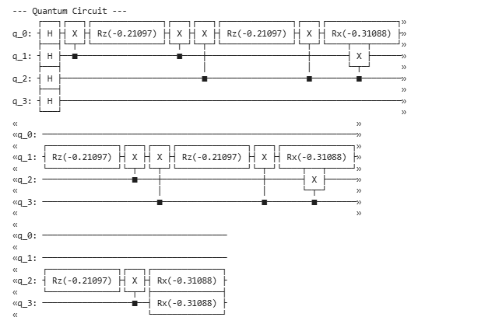
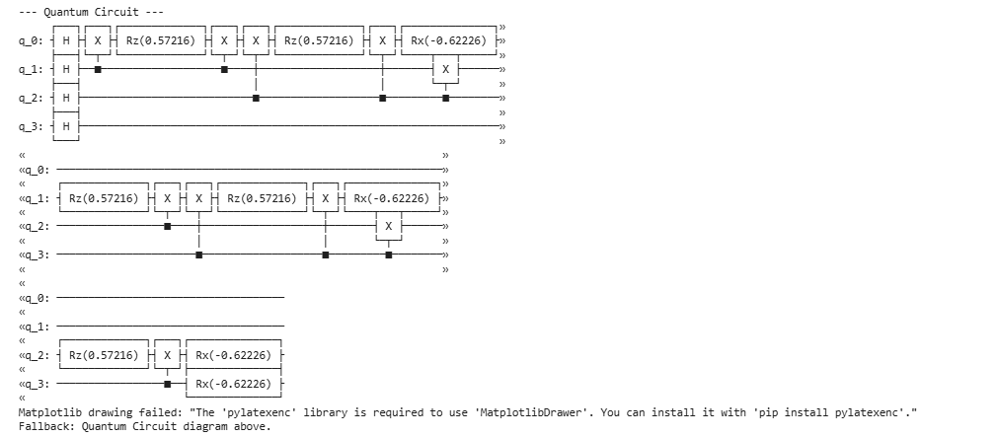

4 Result

The QAOA implementation successfully demonstrates a hybrid quantum-classical optimization approach to solving the Max-Cut problem.

